**2020 02 03**

Simulated rotary data  
We only generate the simplest case: constant angular acceleration  
motion. This yields rotary data ( angular velocity as a function of time)  
Simulated accelerometer data  
Given omega as a function of time for a rigid body ( rotary data),  
simulate radial (x) and tangential (y) accelerations for a sensor  
placed at a given radial distance from the axis of rotation  
hybrid data  
Use experimentala data from a rotary sensor ( angular velocity as a function of time)  
Generate simulated accelerometer data from the real rotary data.

This approach allows a gradual introduction of real-world problems such as:

* richer variations in speeds and accelerations;
* sensor inaccuracies (noise, unexpected zero values )

Some results: reconstruction of rotational parameters  
Recovery of the radial value associated with the simulated accelerometer data.  
  
From constant angular acceleration simulated data:

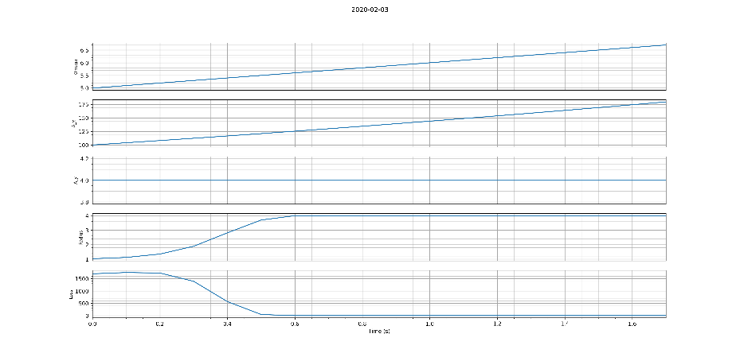  
  
temporally localized reconstruction algorithm  
- Previous reconstruction uses a "global optimization" method, in which r estimate  
 improves as we move through the data  
- The new algorithm uses a "local optimization" method: re-initializes *r* at eachtime step, and iterates multiple times on each time step: a new optimal *r* value for each time step.  
  
  
1. From constant angular acceleration simulated data:

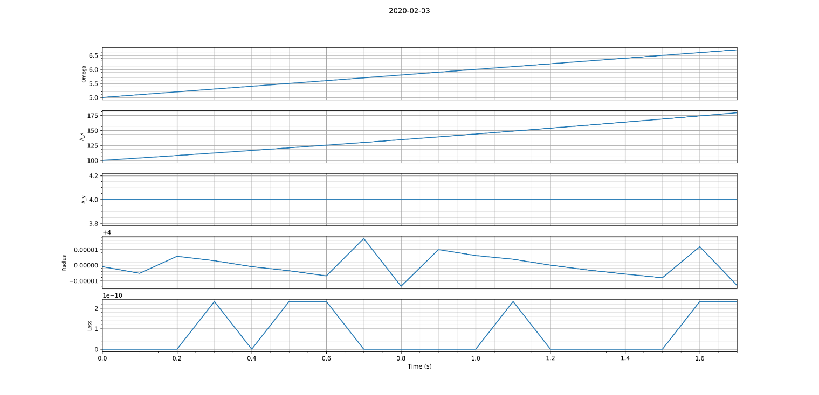

Compare this with the previous graph, which is using the same data set: the local optimization routine performs far worse! And yet we need it..

2. From hybrid data   
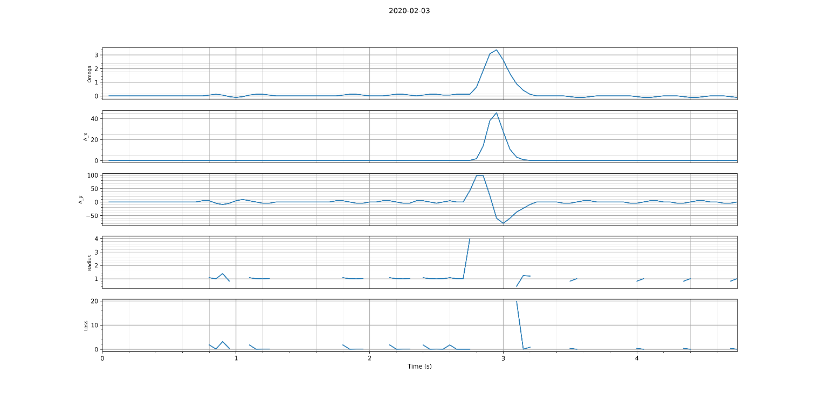  
  
  
next steps  
- sine wave simulated data ( + noise )  
- smoothing data as a preprocessing step